**UNIX Lab Assignment 6**

Name: Sreekesh Iyer Roll No. 24

**Filters and software management commands**:

1. **nl**: nl command is a Unix/Linux utility that is used for numbering lines, accepting inputeither from a file or from STDIN. It copies each specified file to STDOUT, with line numbers appended before the lines. The nl command reads the File parameter (standard input by default), numbers the lines in the input, and writes the numbered lines to standard output. In the output, the nl command numbers the lines on the left according to the fags you specify on the command line.

**Syntax**:

nl [OPTION]... [FILE]… **Output**:

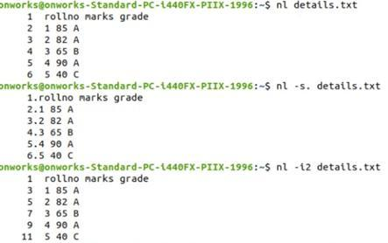

1. **cut**: The cut command in UNIX is a command for cutting out the sections from each lineof files and writing the result to standard output. It can be used to cut parts of a line by byte position, character and field. Basically, the cut command slices a line and extracts the text. It is necessary to specify options with commands otherwise it gives errors. If more than one file name is provided then data from each file is not preceded by its file name.

**Syntax**:

cut OPTION... [FILE]…

**Options**:

$cut -b : $cut -b is used to cut a specific number of bytes from a file and then display it. $cut -d : Instead of selecting x number of characters, if you like to extract a whole field, you can combine option -f and -d. Option -f specifies which field you want to extract, and option -d specifies what is the field delimiter that is used in the input file.

**Output**:

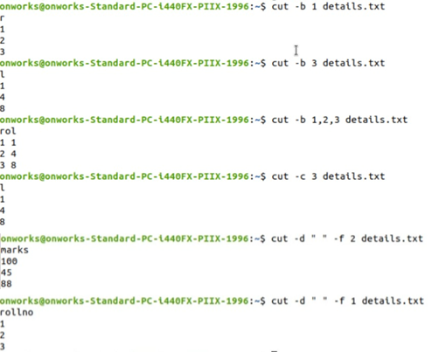

1. **grep**: The grep filter searches a file for a particular pattern of characters, and displays alllines that contain that pattern. The pattern that is searched in the file is referred to as the regular expression (grep stands for global search for a regular expression and print out).

* zero or more characters? exactly 1

+ 1 or more

**Syntax**:

grep [options] pattern [fles]

**Output**:

1. **sed**: SED command in UNIX stands for stream editor and it can perform lot’s offunctions on fle like, searching, fnd and replace, insertion or deletion. Though the most common use of SED command in UNIX is for substitution or for fnd and replace. By using SED you can edit fles even without opening it, which is a much quicker way to fnd and replace something in a fle, than frst opening that fle in VI Editor and then changing it.

SED is a powerful text stream editor. Can do insertion, deletion, search and replace (substitution). SED command in unix supports regular expression which allows it to perform complex pattern matching.

**Syntax**:

sed OPTIONS... [SCRIPT] 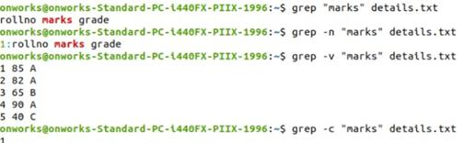

[INPUTFILE...] **Output**:

